CURRENT BRAND

Marvel Enterprises moved from bankruptcy in 1997 to the largest growing stock in the Wall Street Journal. This wonderful change in Marvel Enterprises is owing to its strategic choices in the procurement of innovative talent, a large inventory of superheroes and characters, synergistic investments, good leverage over Marvel's characters, a very efficient value chain, and a competitive marketing strategy.

Marvel originally began with their comics and gradually expanded their product by launching a series of movies based on their own comics. Disney bought marvel studios for $4 billion in 2009.  They're still selling their comics to this day but they ended their movie series with Avengers: end game.  At the moment, they're only focused on launching a few movies based on individual characters and their life stories.

SEGMENTATION AND TARGET MARKET:

* Original segmentation and target market:

Originally, the target market for Marvel Comics was children and young adults and was more targeted at boys than girls. The stereo subgenres were science-fiction and fantasy. The comics became famous and drew a lot of attention. The boys pretended to be warriors and were battling the bad guys. Superheroes were marketed as incredible crimes—fighting real heroes, and they were every boy's fantasy. They caught the hearts of boys worldwide with the concept of being unique with the super-powers and therefore being able to win over evil. The comics were vivid, vibrant, action-packed and thrilling, while the superhero had the hidden identity of 'man by day, superhero by night.'. In the 1940s, America, which appeared on the back pages of Marvel's detective comics, gained a new target market, young girls. She was a female version of the iconic character, Captain America, and soon switched to American female teenagers as their main subject. Features were applied to fashion, beauty and a brand new division of comics has come into being.

* Current segmentation and target market:

When it comes to Consumer Segmentation, there are different classes Marvel positions their target market in categories, such as geographic segmentation, demographic segmentation and psychographic segmentation. Marvel's target audience are between tweens and adults, about the age of 9-60. There are also collectors who buy comic books and keep them to sell for more money years later. For example, in order to draw and sustain their target population of the geographical segmentation, there is British Captain America, which is based in Marvel UK. There is also a demographic category of Marvel characters whose racial heritage originates from across the world. Examples of this include Tomi Shishido (Earth 616), a Japanese version of Wolverine and Natalia Romanova (Earth 1610), a Russian, known as the Black Widow.

An example of Marvel's psychographic segmentation is seen in the image above, the Marvel Pinball. This latest game focuses the target market with iOS and Android smartphones and  was launched at a special cheap price of $0.99 until May 7th, 2012; it's now available on iOS and Android devices as Zen pinball iTunes and Zen pinball THD respectively.

POSITIONING:

* Original positioning:

Marvel’s original position statement was “Our mission to expand enables our legends like Thor and The X-Men to come to life in unexpected ways. To resonate with people today and to evolve with generations to come”.

* Current positioning:

Marvel’s current position statement is “Diversified genres of our legends and storylines allow Marvel to evolve with the generations of today and those to come. Our foundation of originality, imagination, and innovation will be guided by trends supported from our Marvel Universe enthusiasts”.

Marvel has launched a series of their Avengers movies. They were a massive hit in Hollywood, winning billions at the box office, with cult-like fan bases. Marvel has developed and refined the idea of putting together a group of do-no-wrong heroes in a spectacular fight for humanity. A classical narrative of good and wrong. Marvel occupies the position within the minds of customers, and we have little attention for copycats to fill.

The persistence of a plan based on Marvel's top-rankers alone is outdated and no longer possible. Marvel's strategic vision is to diversify its known characters and stories. The target demographic remained the same throughout Marvel's lifetime, and quite honestly, the industry has re-launched itself to become inclusive of far more target audiences that Marvel is not capitalizing now.

CURRENT PRODUCT:

Marvel Comics is a publisher of American comics books. Marvel counts among its characters such well known superheroes as Spider-Man, Iron Man, Captain America, the Hulk, Thor, Wolverine and many more. They also created superheroes teams such as the avengers, the x-men, the fantastic four and other teams. Most of Marvel’s fictional characters operate a single reality known as the marvel universe, with most locations mirroring real-life places. In addition to numerous long-running comic series, these heroes have been transposed to television, cinema and video games. In the 21st century Marvel’s profits were increasingly derived from toys, video games, and other merchandise featuring their most popular characters and from the production of a string of commercially successful movies. In fact, marvel was able to produce movies by taking inspiration from its comic books. Operating under various names since the 1930s, Marvel has produced some of the most recognizable fictional heroes in the United States and captured the imaginations of generations of young fans. In recent years, the company has managed to leverage its decades of experience in the comic book industry to produce some of the biggest films in Hollywood.

PRICING STRATEGY:

There is not much to talk about Marvel’s pricing strategy as it is considered a premium brand by everyone. Marvel’s comics and movies have a lot of fan base and they go crazy whenever a comic or movie releases.

* Original pricing strategy:

In March 1963, the very first issue of Amazing Spiderman 1 was sold for 12 cents. At present, with the inclusion of inflation, the price is 96 cents.

* Current pricing strategy:

However, Marvel comics are distributed for $3.99 and $4.99 for 22 pages, and several shows produce new issues twice per month. Digital editions are usually priced the same thing. With the increasing costs of production, pricing comic books at 96 cents is no longer a feasible choice. So, Marvel came up with a package price plan by selling two free retro comics instead that would woo fans who want more value for money.

PLACE:

The company’s staple product from the very beginning has been its comic books. Over 40 percent of all comic store sales in the United States are published by Marvel, giving it the highest market share by a significant margin. Marvel Comic books are sold in comic stores and from retailers as Amazon, Walmart, Costco and so on. In addition, marvel products can be found on the easily on the internet. Moreover, when a new movie comes out, customer can watch it in most of cinemas. In fact, in recent years, the company has managed to leverage its decades of experience in the comic book industry to produce some of the biggest films in Hollywood. Moreover, movies and videogames are sold in the majority of retail stores and it is very easy for customers to find and buy Marvel products.

Typical cinemas place decisions: Place is divided into two distinct components: 1). Retail and 2). Logistics and Distribution. Focusing on the retail products, place deals with all aspects of the physical location where the transactions occur. This includes the external design and the internal design of the store. External design consists of location, external signage, and windows and displays. Internal design consists of space, internal signage, product display, colours used, lighting, aromas, and sounds.

* Marvel Cinemas External Design:
* Location: The location of the cinemas is usually very accessible for their customers. In fact, the movies are so famous that they are seen in almost the majorities of cinemas.
* Signage: Marvel usually use signages to advertise their product. In fact, they place images of their superheroes in places that are crowed.
* Window and Displays: Marvel always use signages to advertise their product. In fact, in many cinemas is possible to find big signs of the main characters. In this way, marvel pushes their customers to see its movies. Moreover, these signages have bright colours in order to attract the attention of customers.
* Marvel Cinemas Internal Design:
* Space: The cinemas environment is physically simple and very spacious.
* Internal Signage: Graphics, detail and price recognition signs are used to make the cinema more attractive and visual appealing. The signages usually advertise their new movies by showing their superheroes posing on 1:1 scale poster. Moreover, posters are very common in the internal design of Marvel
* Colours used: Usually the colours used are very bright in order to get the attention of the customer. Moreover, by using bright colours, they character express power and energy, influencing their customers in a positive way. In fact, the superheroes usually have costumes with bright colours for that purpose. Moreover, these colours when used on signs, they create an environment that is very attractive for their customers.
* Aroma: Marvel doesn’t have a specific aroma, but for many customers, they associate the signs of the superheroes with the aroma of Popcorns and sweet snacks. In fact, many customers associate their image with cinemas.
* Sounds: To get the attention of their customers, usually motivational music is played. In fact, their movies always have motivational music to give energy to their customers when they are watching their movies.

PROMOTION:

Marvel Studios' marketing strategy involves reaching new target markets and never stop delivering what they want.   Though many may believe their followers are only young kids, that is not exactly true. Teenagers and even their families are committed to these movies. It caught the imaginations of all ages. For this reason, word of mouth and social media help to spread these comics and movies by devoted followers. A lot of people give the movies a fair shot because of the recommendation and they enjoy them. This insight is expanding and the demand is also beginning to expand to other audiences.

Content Promotion is the most effective technique used by Marvel. It is a form of marketing that includes creating and posting online content, such as social media posts, videos, and blogs. This firm has social media pages on many sites such as Instagram, Facebook, Twitter, etc. They used these platforms to drop the gobbets regarding their coming movies and comics. Marvel's primary emphasis was on publishing enticing content on all media channels to draw viewers and sustain the curiosity of the theme. Digital Marketing has allowed Marvel to better interact with its audiences on a psychological basis. Thus, the total viewing is growing.

Marvel Studios has produced one of the most loyal and successful film franchises of all time. These two aspects are rare and impossible to do at the same time. Producing something that gets customers excited and worth coming back to, Marvel has built up a strategic business model to look after.

BRAND EXTENSION

Marvel Comics is interested in introducing a new lines of energy drink.

NEW SEGMENTATION AND TARGET MARKET:

Consumption of energy drinks has been increasing year over year since the past two decades. This rise in consumption of energy drinks has been observed majorly amongst adolescents, teenagers and young adults. Marvel as a brand has a wide range of target market across all ages from 6 to 69 years and above in some cases. Finding an appropriate blend of target market of Marvel and energy drinks is really important. Energy drinks are ideally targeted and consumed by people who want to sound louder and live a more energetic life.

The target market for Marvel’s line of energy drinks can be split across the following Target Markets:

**Target Market 1:**

* This market consists of teenagers and young adults ranging from 16 to 36 years old.
* Target market is a case **Business → to → Consumer**
* This target market consists of people who are fans of or have used any of marvel’s products ranging from its movies to comics and toys.
* These set of individuals are aware of the Marvel brand and purchased one or more of its products.
* The consideration set for this target market is other products offered by Marvel.
* Since the product for this target market does not solve any basic need, instead, it provides the pleasure of drinking an energy drink with Marvel’s characters on it, it is a Hedonic Motive.
* This target audience also consists of individuals who look at energy drinks as an alternative to carbonated drinks.
* In this case the consumer is the decision maker.

**Target Market 2:**

* Here, the target market gets broader as it aims to reach competitors’ customers and any individual looking for a boost in energy levels.
* The age bracket for this target market ranges from 16 to 60 years old.
* Some studies suggest that Males, age between 16 to 60 years are the highest consumers of energy drinks. Hence, Males 16 to 60 years old are the primary target in this market.
* This is the market outside of the Marvel brand, these individuals are unaware of the brand or its products.
* The goal is to target the current consumers of energy drinks. This market aims to tap into consumers of energy drink competitors like Red Bull and Monster.
* This is a Hedonic Motive as it gives extra pleasure by providing more than just by solving the basic need of increasing energy level.
* Target market is a case **Business → to → Consumer**

**Target Market 3:**

* This target market is a completely different market than the two above. The above Target Markets 1 and 2 aim at the Business → to → Consumer aspect of the energy drinks while, this market segment deals with the **Business → to → Business**.

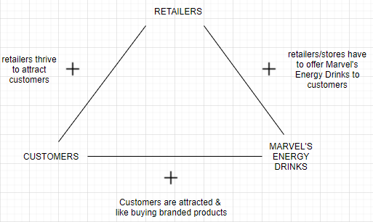

*Figur1: Displays the balance theory between Retailers* **→** *Customers* **→** *Marvel’s energy drinks*

* This consists of retails giants like Walmart, Costco, Amazon, chain of gas station convenience stores and other chain of convenience stores such as 7-Eleven.
* These businesses want people to use their services.
* In this target market the end user and the ultimate decision maker are the customers who buy products from the retail stores and convenience stores.

The three target markets above combined form the target market for the Marvel’s line of energy drinks.

NEW POSITIONING:

The positioning for this product line has a different approach than competitors. Marvel has a lot of characters/superheroes which need to be displayed on its product. Displaying all these characters across a variety of flavours across its line of energy drinks will help Marvel stand out amongst its competitors. With the price structure lower or on par with the competitors, Marvel’s line of energy drinks offers a higher variety of flavours and a difference in its packaging as every different flavour would display a different Marvel character.

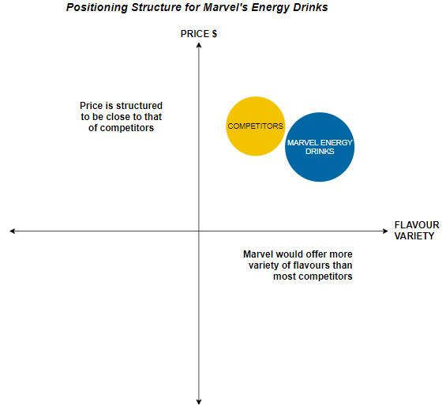

*Figure 2: Displays the positioning structure for Marvel’s energy drinks*

The ultimate goal is to make sure that the consumer of this energy drink not only enjoys this product but also desires to buy this product again in the future. The consumers of this product are expected to return and make repeat purchases of same or different variety of the Marvel’s line of energy drinks. A sense of boost of energy with a new flavour with a different Marvel character on it expected.

NEW PRODUCT LINE:

Marvel is trying to introduce a new line of energy drinks. This line of energy drinks will include a variety of different flavours and tastes. To better explain, each can of energy drink will have different characters on it. Each character is then associated with a specific taste. To better explain, the colour of the costume of the superhero could be associated with a specific flavour. For example, wolverine is associated with the colour yellow, so in the energy drink line he will be associated with the lemon flavour. In a similar way, Spiderman could be associated with the strawberry flavour. Moreover, some flavour could be mixed in order to get a new exclusive flavour. For this specific case, superheroes groups as the avengers could be used on the cover of the can.

NEW PRICING STRATEGY:

Pricing strategy refers to method companies use to price their products or services. The goal is to understand how much the customer is willing to pay for the product. There are several different pricing strategies. Pricing includes the following five strategies:

* Cost-plus pricing: simply calculating costs and adding a mark-up.
* Competitive pricing: setting a price based on what competition charges.
* Value-based pricing: setting a price based on how much the customer believes what is the worth of the product or service offered.
* Price skimming: setting a high price and lowering it as the market evolves.
* Penetration pricing: setting a low price to enter a competitive market and raising it later.

So, for this specific line of energy drinks Marvel should keep the prices low at the beginning to push their customers and fans to try the product. Initially they should keep this penetrating price, so people are more likely to buy their products in order to save some money. After the first period of time, they should rise a little bit the price and see if they can find a balance between all the points previously stated.

NEW PLACE DECISION:

The line of energy drinks lies within the retail aspect of the place where the product will be sold. In this case an intricate blend of **Business → to → Consumer** and **Business → to → Business** aspect is used. The line of energy drinks will be sold at Retailers like Walmart, Metro and Costco; at chain of convenience stores such as 7-Eleven, chain of gas station convenience stores and also at E-commerce retailers like Amazon. Since energy drinks are a retail product, place deals with all the aspects of the physical location where the transaction occurs. Factors of both the Internal and the External design ultimately affect the sales figures.

**External Design**

* In terms of the location of the retailers, Marvel’s line of drinks will be sold through retailers which have optimum physical locations. These locations are easy to find and will attract heavy traffic of customers.
* Retail places such as Walmart, Costco and Metro are easy to access and have appropriate signage which attract the customers to enter and shop at their stores.
* The chain of gas station convenience stores and other chain of convenience stores have high foot traffic. These stores are strategically located to attract a lot of customers and have attractive signage outside their stores. Their customers ideally buy refreshments and drinks on their visit to the store.
* Signages outside the convenience stores displaying the line of energy drinks can attract a lot of customers to buy the product.
* Windows and displays of the convenience stores will also display Marvel’s energy drinks to create awareness and the presence of the brand amongst the customers entering the stores.
* All these locations suffice the needs of the external design thus making them a suitable place to sell the line of energy drinks.

**Internal Design**

* These are the factors which are seen and experienced by the customers when they are actually inside the stores to buy products.
* Location inside retail stores: Marvel’s energy drinks would derive high sales when placed in the aisle for beverages and drinks. Placing the drinks strategically on shelves besides the energy drink giants like RedBull and Monster will help attract more customer attention. Figure 3 below displays the location where the energy drinks would be placed.

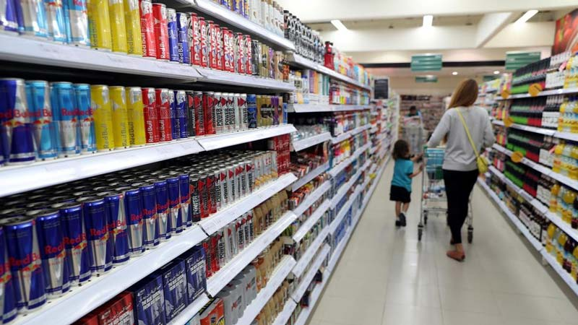

*Figure 3: Displays where the line of energy drinks can be placed in a retail store*

* Location inside retail stores: Another strategic location within the retail outlet is near the checkout lanes. Drinks displayed in the vicinity of checkout lanes have high exposure, this increases the chances of sales of the product.
* Location inside convenience stores: Visits to gas station convenience stores or chains of convenience stores are made to buy refreshments and drinks. Here the product which is most visible is likely to be bought by the customer. Placing Marvel’s energy drinks in the coolers at these stores increases the visibility of the product. Figure 4 below displays the location where the energy drinks would be placed.

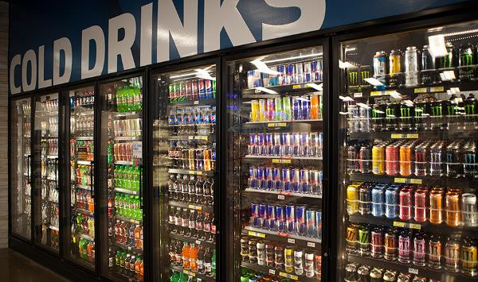

*Figure 4: Displays where the line of energy drinks can be placed in a convenience store environment*

* Variety of factors are to be considered when displaying the energy drinks inside a convenience or retail setup. Some of the factors are mentioned below.
* Space: The line of energy drinks will be displayed on the shelves in a way that sufficient space is available for customers to move freely especially in these unprecedented times of Covid-19 pandemic.
* Signage & Colours used: Signages with bright colours from the Marvel’s characters will be used. There will be sufficient signages across the aisle of energy drinks inside the retail outlets. For the convenience stores, signages will be present besides the coolers and in the area besides cashiers/checkout.
* Lighting: Sufficient lighting inside the coolers at convenience or retail setup is necessary as this helps in clearly displaying the product.

NEW DETAILED PROMOTIONAL PLAN:

* **Images:**

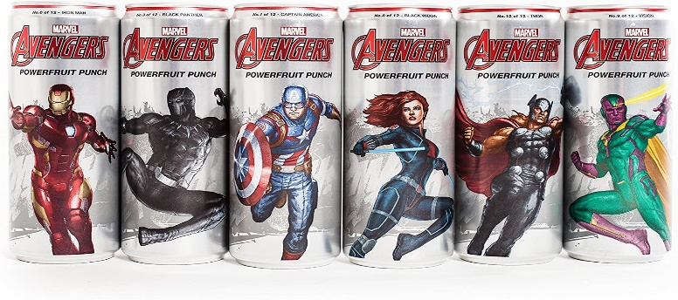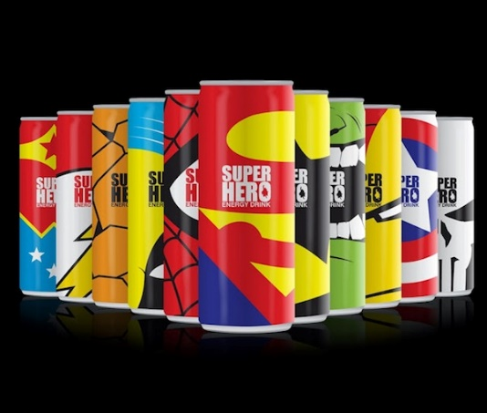

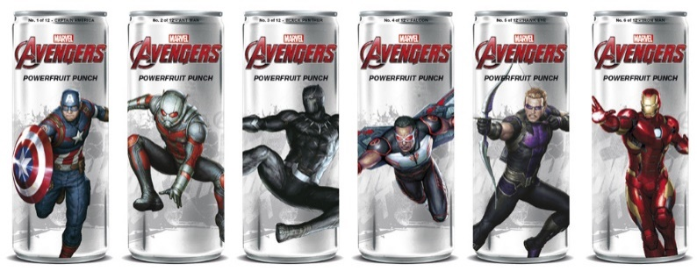

* **Messaging:**

Tagline: ‘AWAKEN YOUR INNER SUPERPOWER’.

People who buy energy drinks are generally exhausted and need a lift to start their productive day. With Marvel energy drinks, we want to bring something into our message that applies to the superheroes or their powers. In our message, the super-power shows the energy that our target market requires to start working or conquer their laziness.

* **Media**:

Advertising can be split across two methods: Traditional Offline and Online. Advertising offers a variety of benefits because a business can communicate their product to their target market and it is all controlled.

Traditional offline methods to be used for advertising Marvel’s energy drinks are:

* Advertisement in a Newspaper, in a sports magazine, on the Radio, on Television, on bus stops and on billboards.
* Another option is organizing promotional events and sponsoring sports events.
* Digital billboards are another popular source of advertisements. Promoting the energy drinks on digital billboards at sports events creates the brand awareness immensely.
* This type of advertising has a potential to reach even outside the target market creating an opportunity to gain new customers.

Online methods to advertise Marvel’s energy drinks are:

* Online advertisement for the energy drinks would be through social media applications such as Facebook, Instagram, Twitter, Snapchat and TikTok
* The target market reached through these social media applications is more precise because the tools offered by them allow accurate penetration of the potential buyers. This results in lower customer acquisition cost compared to traditional methods.
* Another method is buying space on a website. A click through rate (CTR) method will be used for this method as it makes sure the consumer has engaged themselves in the advertisement.
* **Timing**:

Timing is the most important factor of an advertising campaign. The timing for the offline method varies in certain aspects.

Timing for offline advertising methods to be used for Marvel’s energy drinks are:

* A mixture of the three that is pre-launch, launch and seasons is to be considered.
* Marvel’s presence increases exponentially around and after the time of the release of a Marvel movie. This is a seasonal factor for advertising the Energy drinks. Two-fourths of the promotions for energy drinks will take place around and after the release of a Marvel Movie.
* Ideally, a Marvel movie is released every year. The Pre-Launch advertisements for the energy drinks will be positioned at the peak of the sales of the movie tickets for the movie released before the launch of the energy drinks. Approximately one-fourth of the share for the energy drinks will go towards the pre-launch advertisements.
* One-fourth of the promotional efforts to advertise Marvel’s line of energy drinks will be positioned at the time of launch of the drinks. This will give a boost to the already existing awareness about the product amongst the potential buyers.
* **Expected Outcome:**

Marvel has already positioned itself as a product of its kind in the minds of its target markets with its comics and movies. When it comes to our latest line of energy drinks, we are sure that all Marvel fans will be waiting outside the stores to get their hands on them. In the early stages, profits can be expected as this new product is focused on the Marvel characters. But we certainly need to be mindful that there are established rivals like red bull with a large customer base, and winning such customers can be a difficult task. In cannot be achieved in the short term, but with word of mouth and better promotional tactics we would expect them to switch to our energy drinks in the long run.